CSB 353: Compiler Design

Project Synopsis (Parser for P3SQL)

Submitted By:

Prashant Borkar (191210036)

Prem Kumar (191210037)

Prince Kumar (191210038)

Submitted To: Dr. Shelly Sachdeva

Department of Computer Science and Engineering



NATIONAL INSTITUTE OF TECHNOLOGY DELHI

2019-2023

Index

|  |  |  |
| --- | --- | --- |
| S No. | Content | Page No |
| 1 | Project Introduction | 3 |
| 2 | Scope of the Project | 4 |
| 3 | Sample Input | 5 |
| 4 | Software and Hardware Requirements | 6 |

Project Introduction

We will be creating a Parser for a Structured Query language which will be a new language designed by ourselves (i.e P3SQL). We will be creating it in python making the use of lex and yacc and we will be connecting it with MySQL Database.

Lex is a part of lexical analyzer and yacc is a part of syntax analyzer. Lex takes source code and produces tokens as per the input statement and yacc takes these tokens and generates a Parse Tree.

**Flow Chart:**

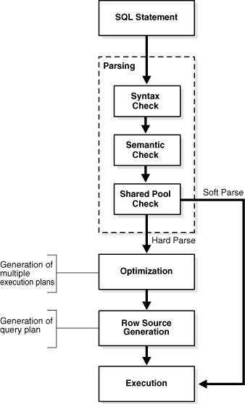

Scope of the Project:

* **Type**
  + STRING
  + INTEGER
* **Statement**
  + CREATE DATABASE
  + DROP DATABASE
  + SHOW DATABASES
  + USE DATABASE
  + CREATE TABLE
  + DROP TABLE
  + SHOW TABLES
  + INSERT
  + DELETE
  + UPDATE
  + SELECT

Inputs can be given through the input file or through terminal.

Sample Input:

* Rules

S → select * from exp/

select * from exp where exp = exp/

and exp=exp

exp→ TableName/Name

TableName → [a-zA-Z0-9]

Name →[a-zA-Z]

Ex: CREATE DATABASE TEMP;

SHOW DATABASES;

USE TEMP;

SELECT * FROM STUDENT

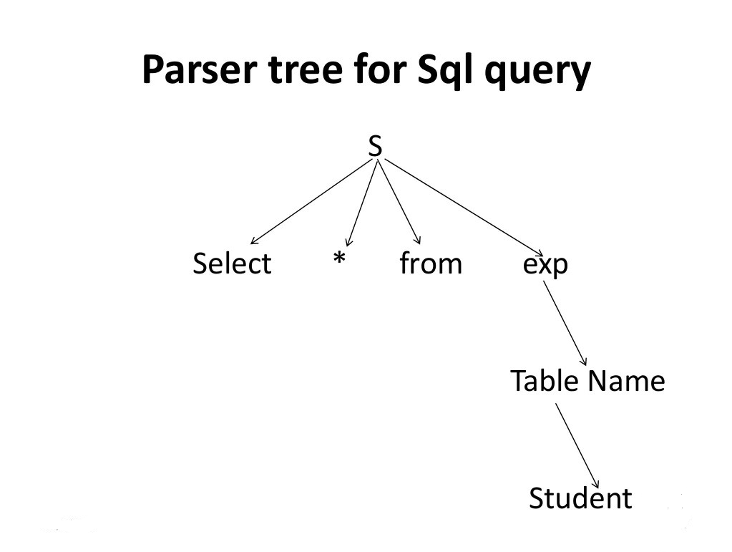

Parse Tree for Above Query

Software Requirements:

* Python 3
* PLY

PLY is yet another implementation of lex and yacc for Python. Some notable features include the fact that it is implemented entirely in Python and it uses LALR(1) parsing which is efficient and well suited for larger grammars.

* PyMySQL

This package contains a pure-Python MySQL client library.

* MySQL
* VS Code(ide)

Hardware Requirements:

* Windows/Linux Operating System
* Memory (RAM): 512 MB of RAM
* Memory (Hard disk): 100 MB of free space